TASK | Multi surface cleaner which can be used on all hard surfaces
LOCATION OF USE | Workshop and field engineers |  | Assessment  No |  | 034
PRODUCT NAME | Magnasol Hard Surface cleaner
DESCRIPTION OF SUBSTANCE | Fluorescent green liquid
MANUFACTURER | Matric Service and Supplies Ltd
MANUFACTURERS CONTACT | Unit 25/26  Essington Ind Estate  Bognop Road  Essington  Wolverhampton  WV11 2BJ  Tel: 01922 479132
ASSESSOR | Martin Monaghan CMIOSH |  | Date |  | 04 12 25
TITLE | Health and Safety Consultant |  | Review by |  | 04 12 27
Personnel Performing Task  (Please list below)  Technicians/ Fitters/ Workshop Operatives |  | Time Spent  (Minutes/day)  As and when required, amounting to a few minutes per day | Training Given 
 |  |  | Yes

MSDS Revision Date | Hazard Statement
05-01-2019 Rev 1 | H314: Causes severe skin burns and eye damage

Assessment to be conducted in Association with Hazard Data Sheets, a full current copy of which must be attached to this assessment.

Please denote the hazardous properties of the substances used in the task with a 

NEW INTERNATIONAL GLOBALLY HARMONISED HAZARD SYMBOLS
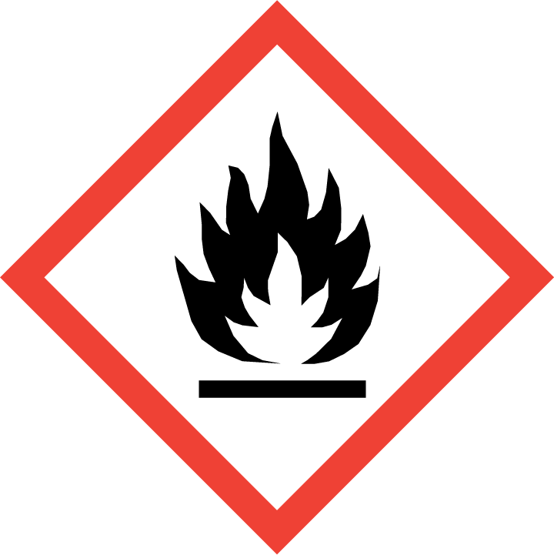 | 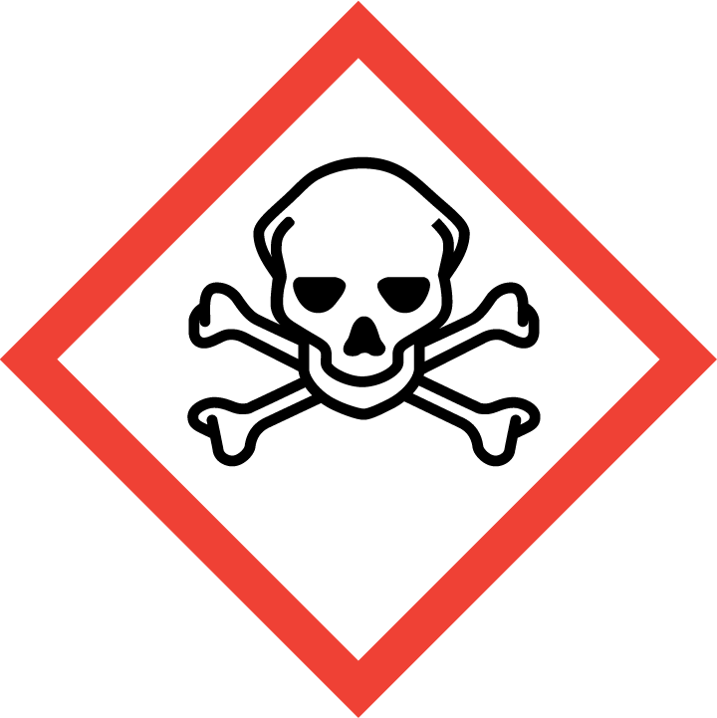 | 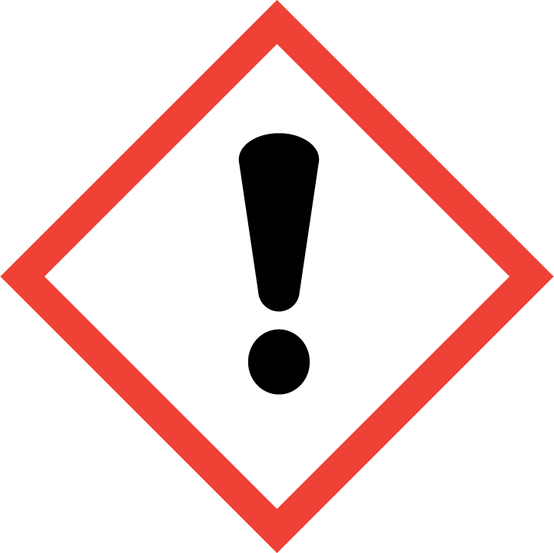 | 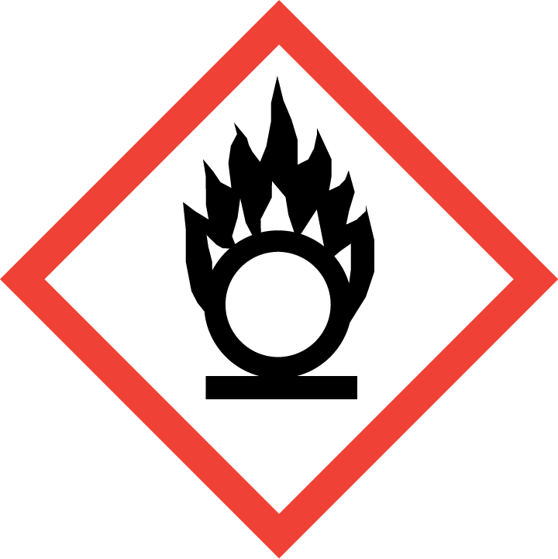 | 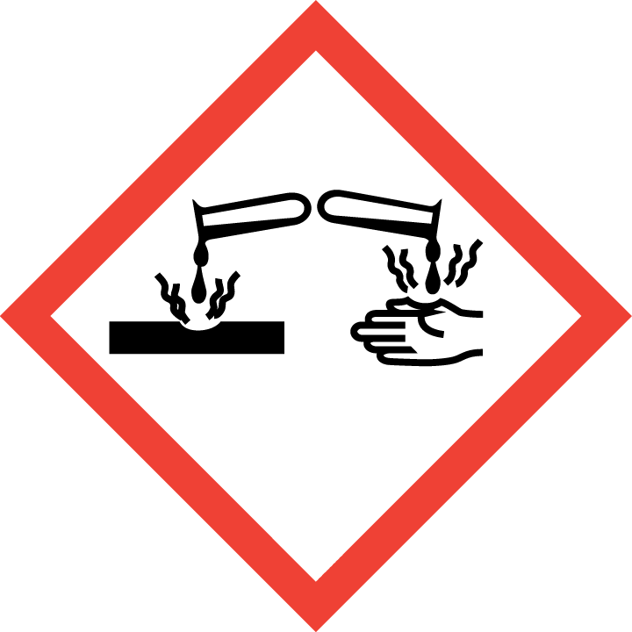 | 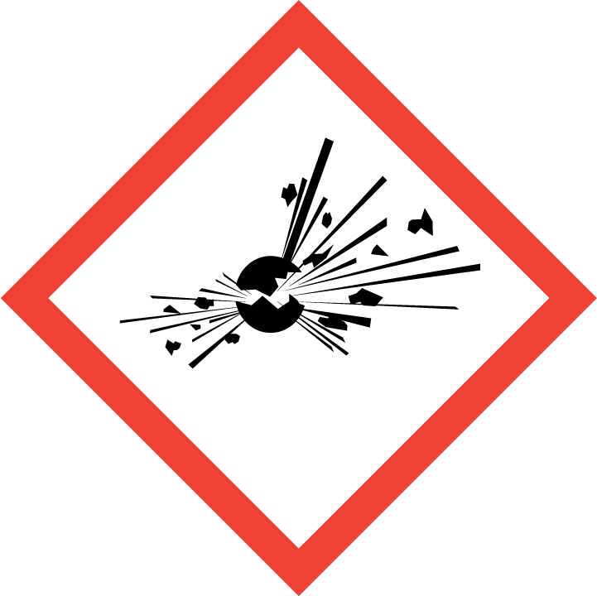 | 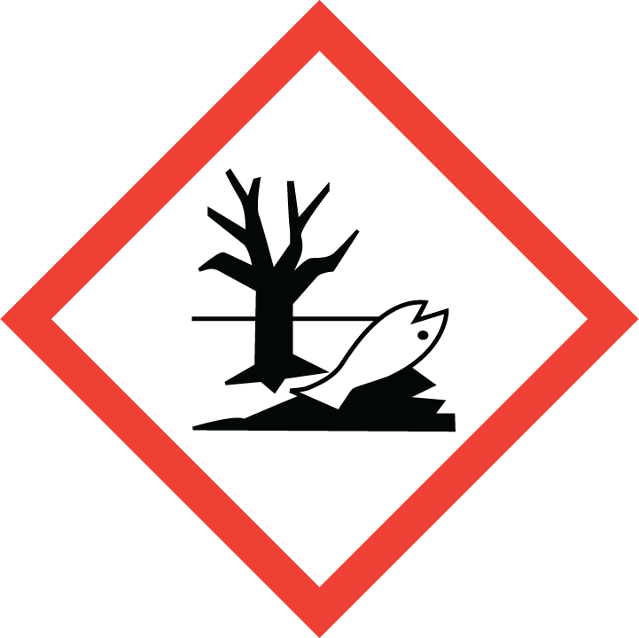 | 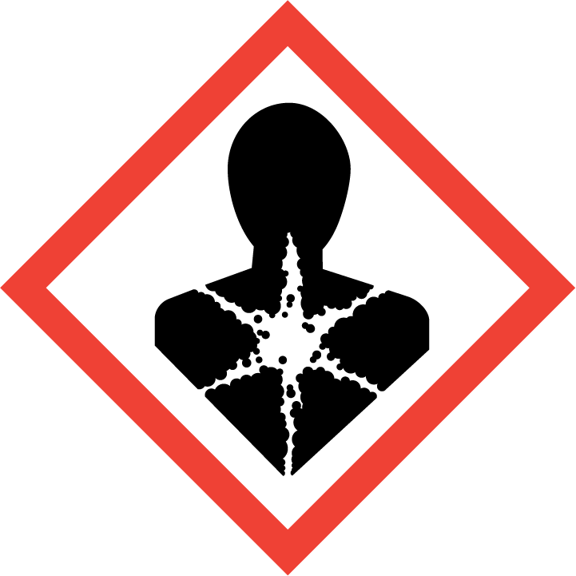
Flammable | Toxic | Harmful | Oxidising | Corrosive | Explosive | Harmful to the environment | Health Hazards i.e. respiratory sensitisation or carcinogenicity
 |  |  |  | 

SMOKING, EATING AND DRINKING ARE PROHIBITED IN THE WORK AREAS.
Information, Instruction and Training must be provided to all users. Young Persons, New or Expectant Mothers and other vulnerable groups must not use or be exposed to this product.

WORKPLACE EXPOSURE LIMITS (WEL’s)
IMPORTANT!
Refer to Workplace Exposure Levels information provided in the Manufacturers Safety Data and revise control measures if exposure levels likely to be reached.

ROUTE OF EXPOSURE
Skin |  | Eyes |  | Inhalation | 
Ingestion |  | Cuts/abrasions |  | Systemic

PERSONS AT RISK
User of product |  | Co workers |  | Members of the public

ROUTE OF EXPOSURE |   FIRST AID MEASURES
Inhalation | Remove casualty from exposure ensuring one's own safety whilst doing so. Consult a doctor
Skin contact | Remove all contaminated clothes and footwear immediately unless stuck to skin. Wash immediately with plenty of soap and water.
Eye contact | Bathe the eye with running water for 15 minutes. Consult a doctor
Swallowing | Wash out mouth with water. Consult a doctor
In all cases of doubt, or if symptoms persist seek medical attention. Never give anything by mouth to an unconscious person. If unconscious, place in recovery position and seek medical advice.

PERSONAL PROTECTIVE EQUIPMENT
 |  | 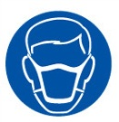 |  | 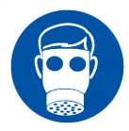 |  | 
YES | YES | YES/NO |  | YES/NO | YES | YES/NO
 |  |  |  |  | 
YES | YES |  |  |  | YES - Chemical Resistant

HANDLING | STORAGE | TRANSPORT | DISPOSAL
Avoid direct contact with the substance. Ensure there is sufficient ventilation of the area. Do not handle in a confined space. Avoid the formation or spread of mists in the air. | Store in a cool, well ventilated area. Keep container tightly closed |  | Must not be disposed of with household waste. Used, degraded or contaminated product may be classified as hazardous waste. Return empty aerosols to the factory for disposal.

REQUIRED CONTROL MEASURES
- Ensure only minimum amounts of multi surface cleaner are stored on site.
- Ensure approved impermeable gloves are used at all times.
- Ensure appropriate eye protection is worn.
- Ensure overalls are worn and these are suitably laundered.
- Ensure that work is undertaken in well ventilated areas.
- Ensure that Engineers are equipped with antibacterial hand washes and wipes and that good hygiene practices are enforced.
- Wash hands thoroughly after handling.

FIRE PRECAUTIONS
This product is not flammable. Use fire-extinguishing media appropriate for surrounding materials.

ACCIDENTAL RELEASE/SPILLAGE PROCEDURES
Avoid any contact with the skin and eyes. If a large quantity has been spilt, evacuate all personnel and only allow intervention by trained operators equipped with safety apparatus.

MONITORING REQUIREMENTS AND HEALTH SURVEILLANCE
Health surveillance is not in place for workers exposed to this product.

